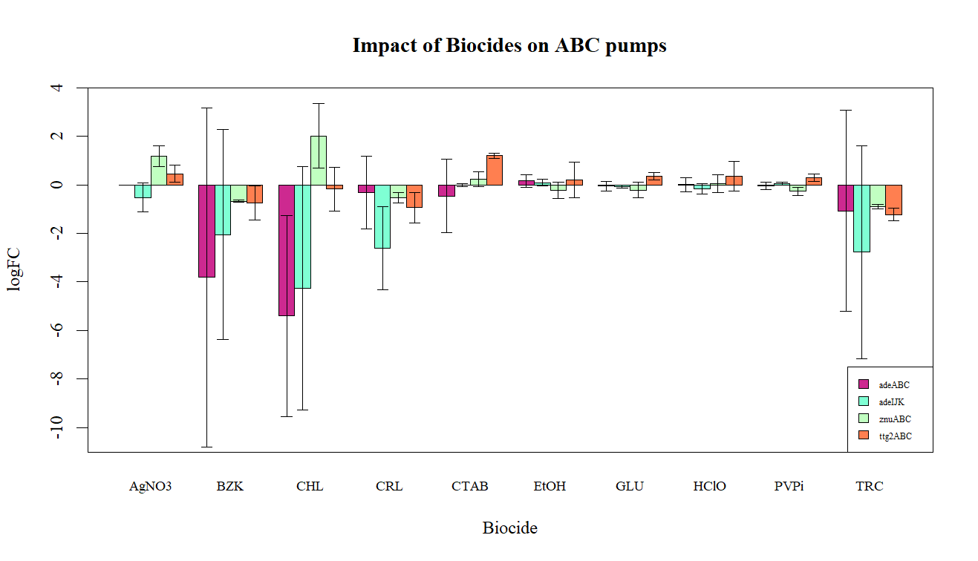

**FIG 2.** Mean (±95%CI) ABC gene family logFC measurements, organised by biocide treatment (n=3). Note that the value logFC for each biocide is the average logFC of the three constituent A, B and C genes in each family.

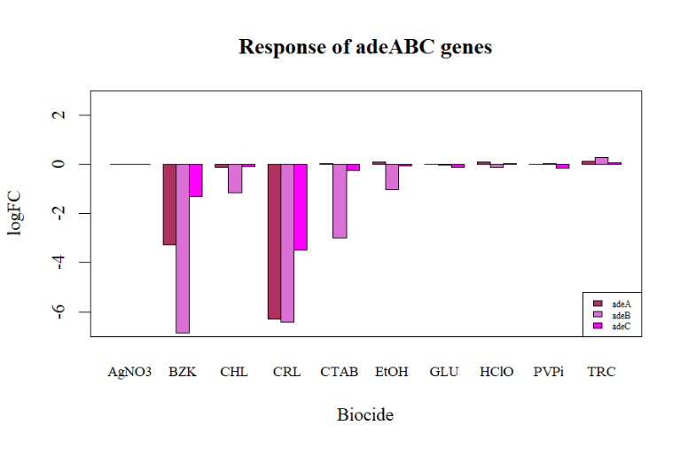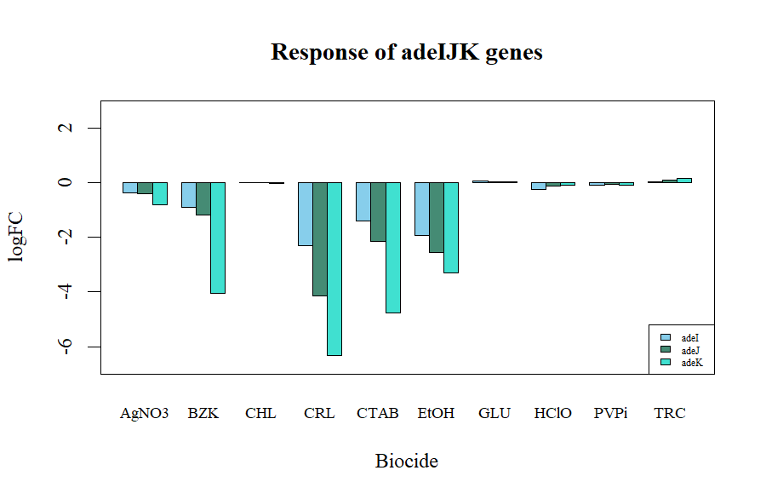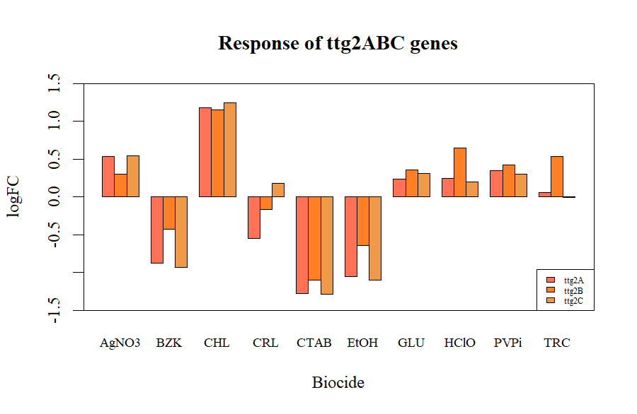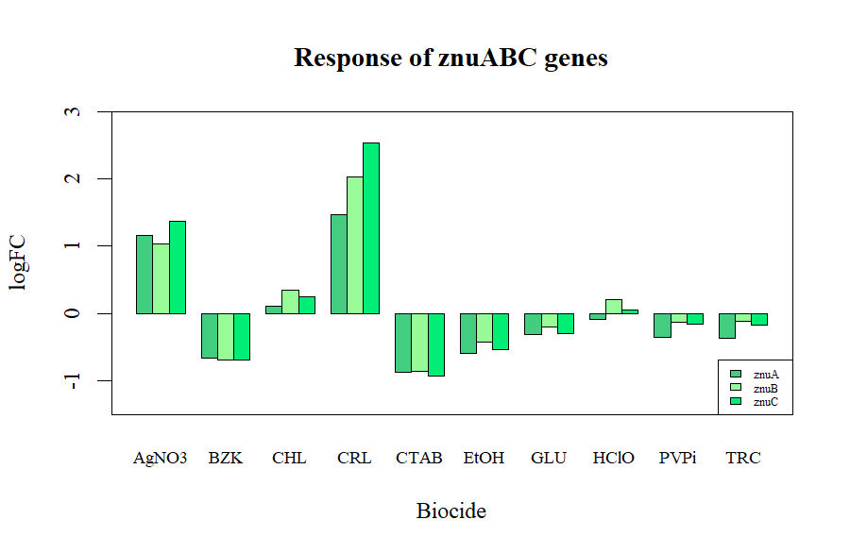

**FIG 3.** logFC measurements of A, B and C genes for each ABC gene family. **a)** adeABC, **b)** adeIJK, **c)** ttg2ABC, **d)** znuABC

**a)**

**b)**

**c)**

**d)**

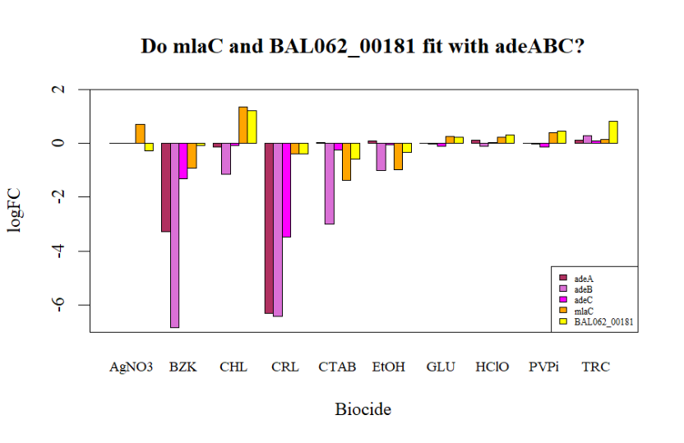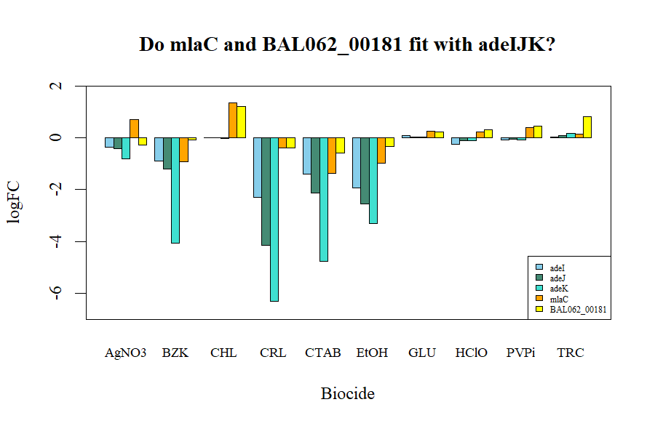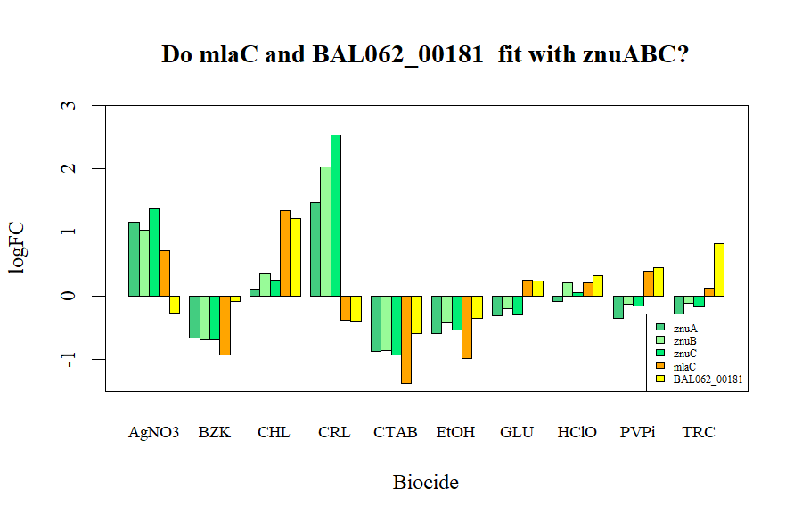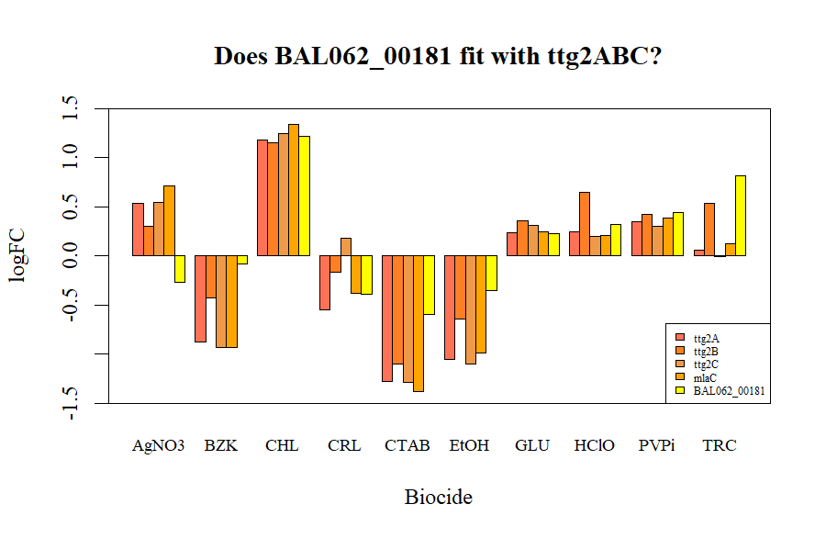

**FIG 4.** Comparison biocide logFC profiles of the hypothetical protein BAL062_00181 and the ttg2ABC-associated protein mlcA against each ABC family: **a)** adeABC, **b)** adeIJK, **c)** ttg2ABC, **d)** znuABC

**a)**

**b)**

**c)**

**d)**

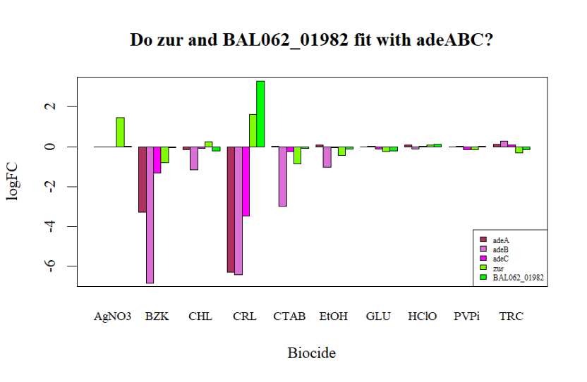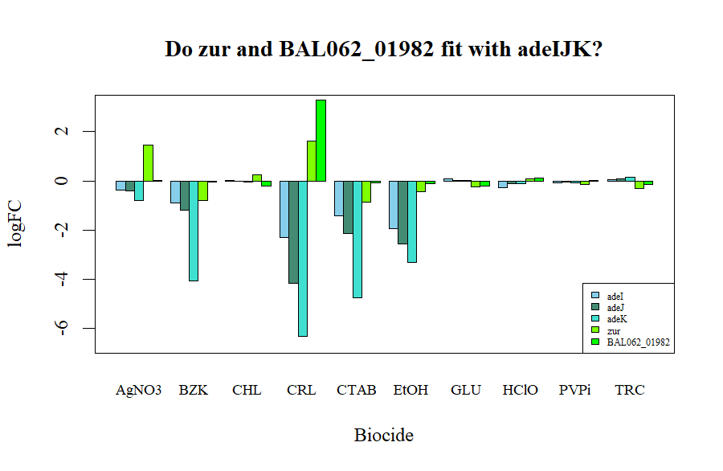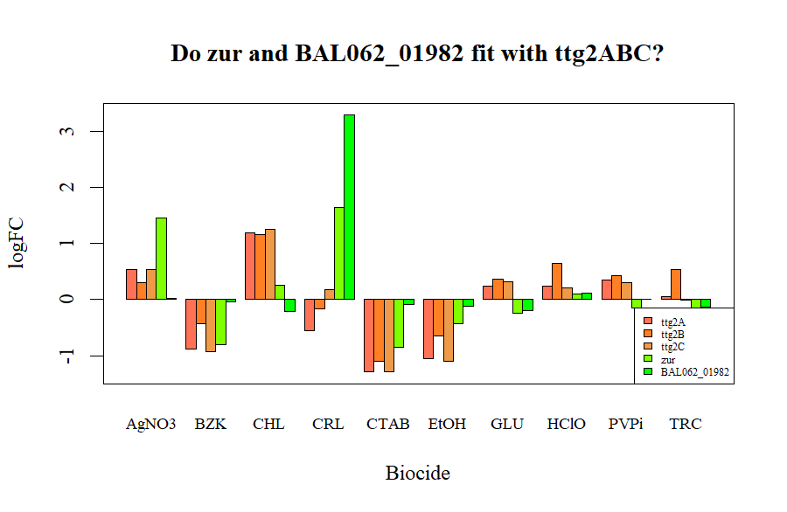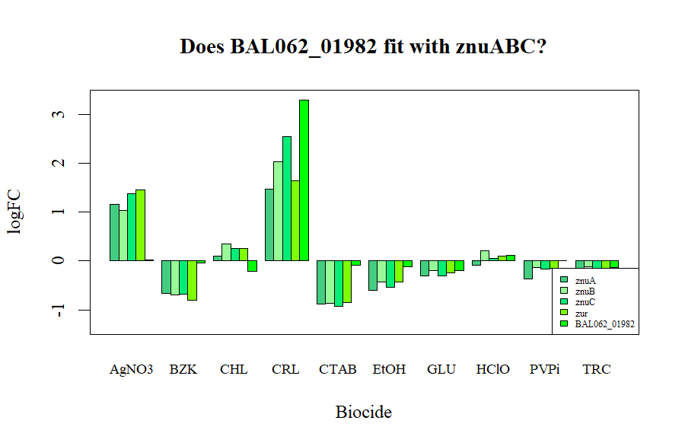

**FIG 5.** Comparison biocide logFC profiles of the hypothetical protein BAL062_01982 and the znuABC-associated protein, zur, against each ABC family: **a)** adeABC, **b)** adeIJK, **c)** ttg2ABC, **d)** znuABC

**a)**

**b)**

**c)**

**d)**